Database Development and Class Registration

Ethan Meier
CST499: Capstone for Computer Software Technology
Charmelia Butler
November 10th, 2025

This paper continues the development work that started in Week 3. The goal of this phase was to finish the database setup, connect the PHP pages to the backend, and complete the remaining features for the student class registration system. These features include creating tables in MySQL, registering for classes, listing registered classes, adding new courses to the semester, and deleting classes from a schedule. This paper describes the new work completed this week, shows screenshots of the database before and after each operation, and includes screenshots of the PHP files that handle the logic. The main purpose of this paper is to show the progress made during the implementation phase and explain the experience of putting all the parts together.
Database Tables Created
Two new tables were added to the MySQL database during this phase. These tables were created inside the cst499 database using phpMyAdmin. The tables are called courses and registrations. The user’s table was already created during the earlier part of the project, so it was not changed.
Courses Table Structure
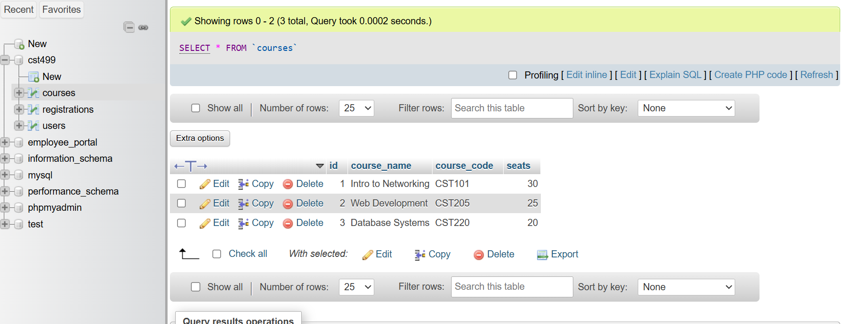
Registration Table Structure
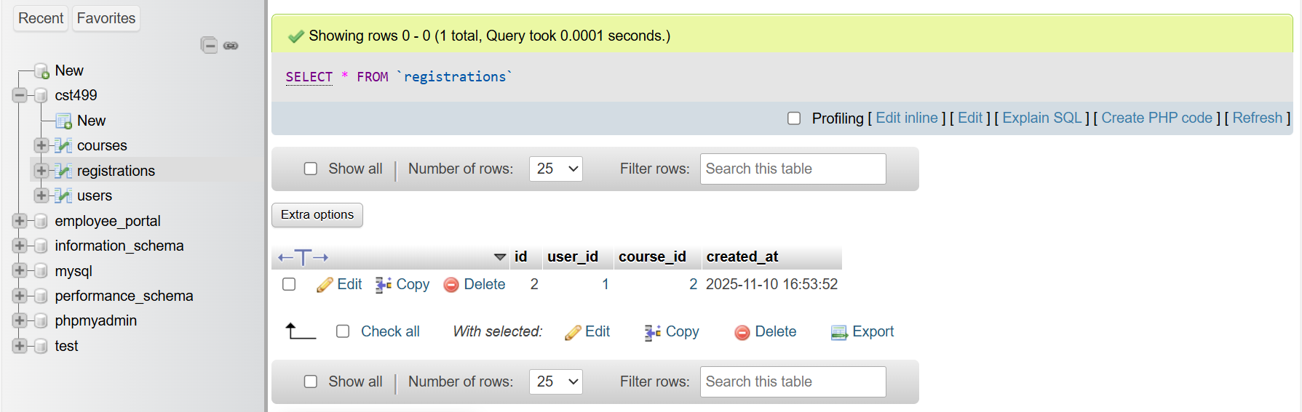
After the tables were created, I added three sample courses to the courses table. These courses were Intro to Networking, Web Development, and Database Systems. The screenshot below shows the courses that were added.
Courses Table With Sample Data
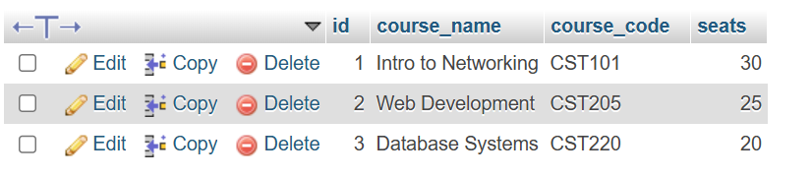
Registering for a Class
To test the registration process, I opened the register_class.php page in the browser. At first, the registrations table was empty.
Registration Page
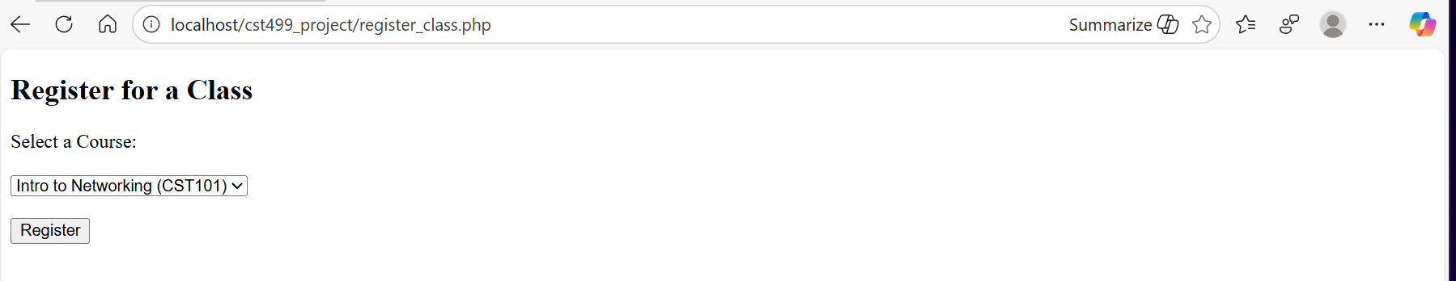
After submitting the form, a new row was added to the registrations table for user_id 1 and course_id 1. The browser also showed a message that the class was registered successfully.
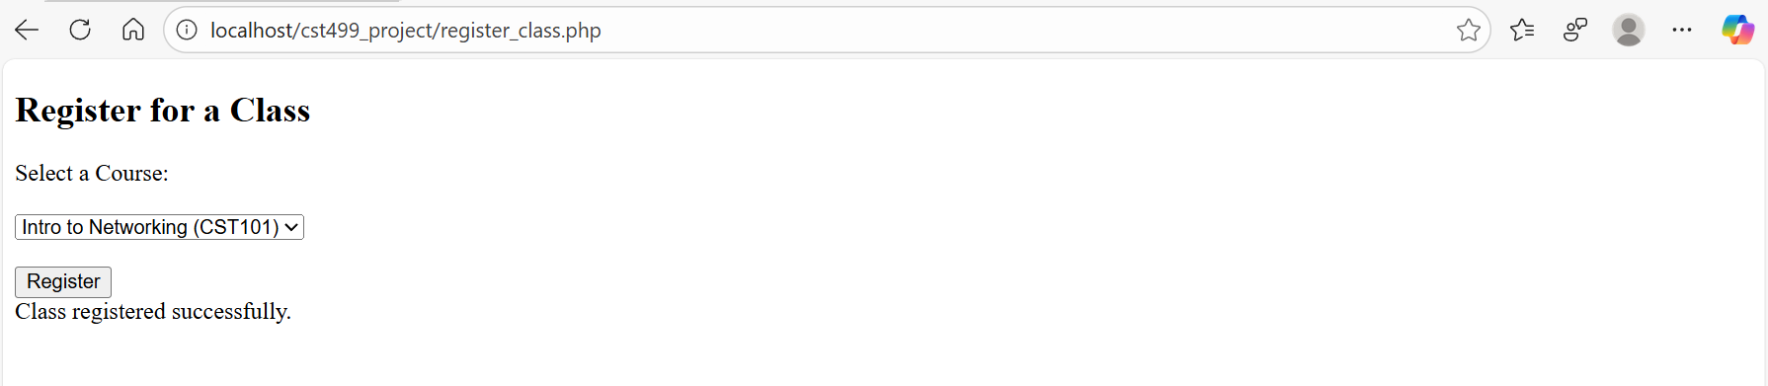
Listing Registered Classes
The next feature was the page that displays the classes a student is registered for. The page pulls data by joining the registrations table with the courses table. When the page loaded, it showed the course that was registered in the previous step.

Adding Additional Classes
Another required task was adding more courses to the semester. The add_class.php page uses the same dropdown list from the courses table. When the form was submitted, the page showed a success message and added another row to the registrations table.
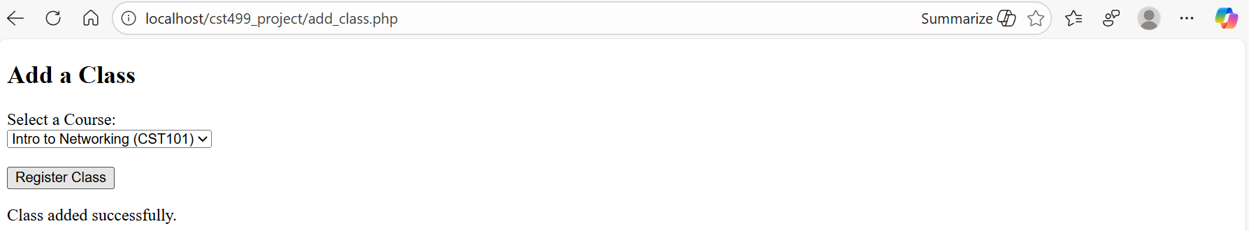
Deleting a Class
The delete_class.php page allows a student to remove a class from their schedule. After selecting a class and submitting the form, the page showed a message confirming that the class was removed. The registrations table also updated and removed the row.
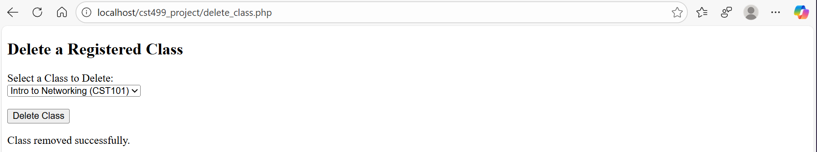
PHP Code
The new PHP pages that were created this week include:
- register_class.php
- my_classes.php
- add_class.php
- delete_class.php
register_class.php Code
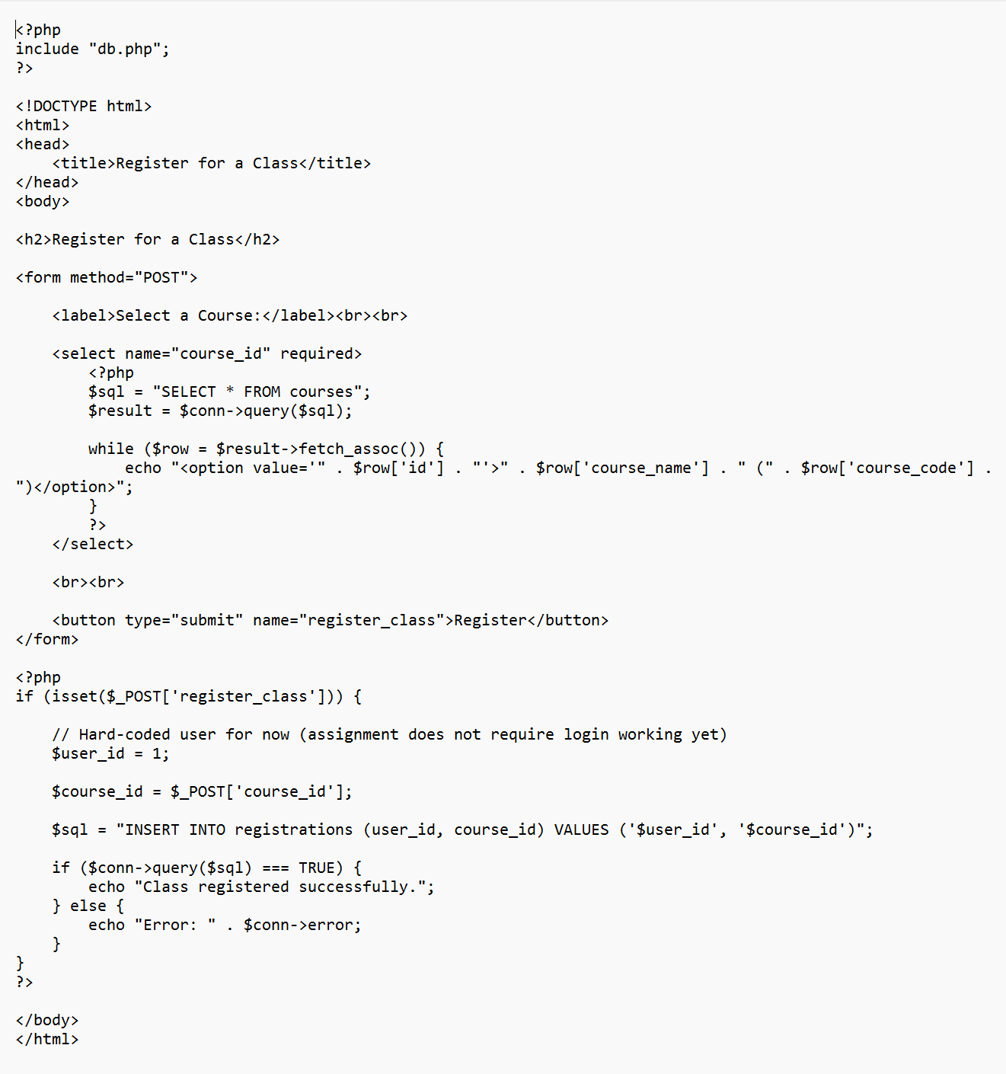
my_classess.php Code
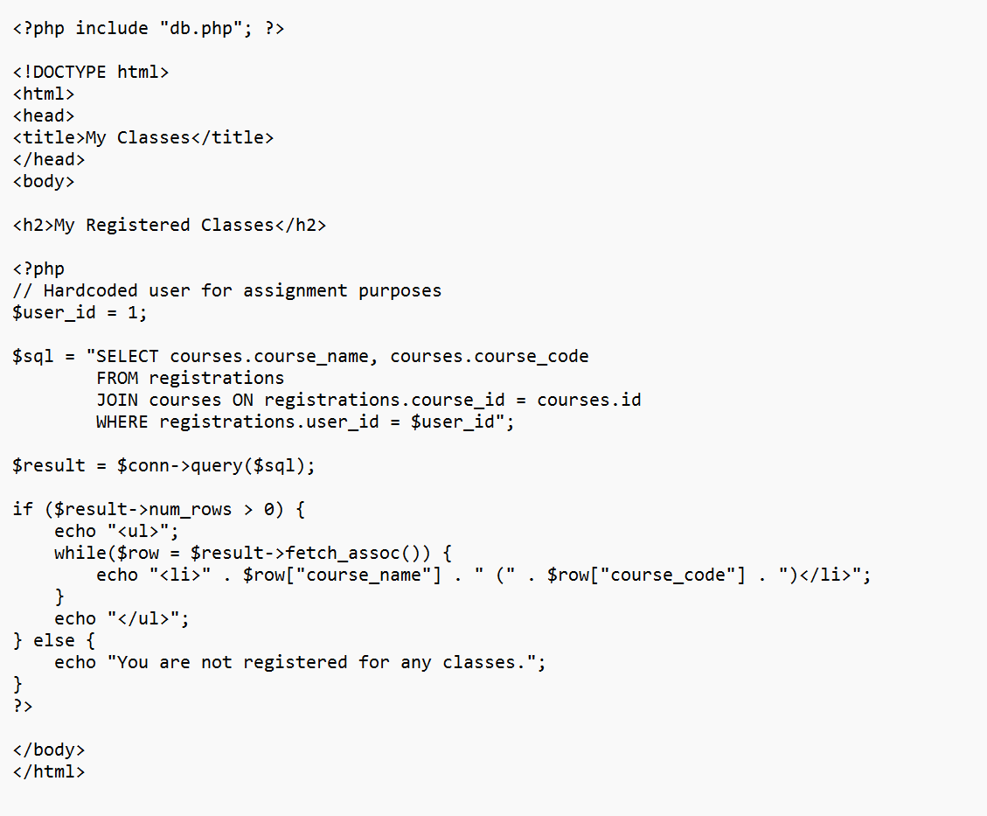
add_class.php Code
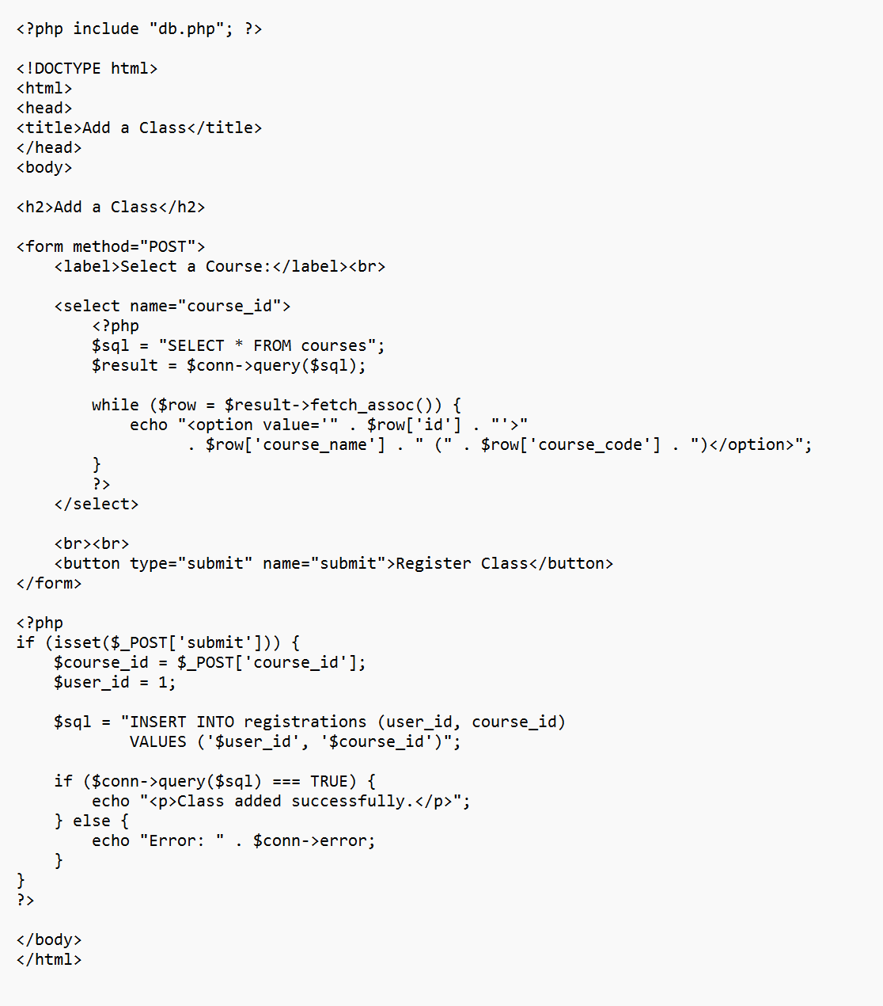
delete_class.php Code
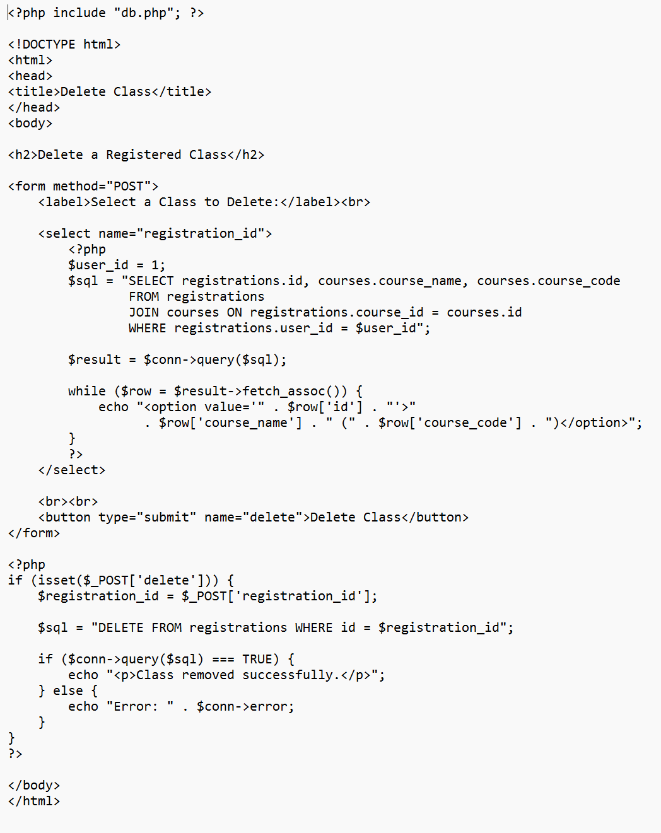
Experience During the Implementation Phase
This phase of the project helped connect the front end with the database and complete the system workflow. Creating the tables in phpMyAdmin was straightforward once the structure was planned out. The biggest learning experience involved keeping the SQL queries simple and making sure each page pointed to the correct connection file. Another part that was helpful was watching how the database changed before and after each operation. This made it easier to confirm that the PHP code was working correctly. Overall, this phase made the project feel more complete because all parts of the system were finally linked together and functioning as a single application.
This week continued the development phase by completing the database, adding the remaining features, and connecting the pages to the backend. The courses and registrations tables were built, and the system now supports registering for classes, viewing registered classes, adding more classes, and deleting classes. The screenshots in this paper show the database operations and the working pages. This part of the project improved my understanding of PHP and MySQL and helped me gain experience building a working web application. The work completed in this phase prepares the project for the final stages in the upcoming weeks.

References
Sommerville, I. (2016). Software engineering (10th ed.). Pearson.
Powers, D. (2017). PHP, MySQL, and JavaScript: A step-by-step guide to web development. O’Reilly Media.
Oppel, A. J. (2019). Databases demystified (3rd ed.). McGraw-Hill.
Beighley, L. (2017). Head First PHP & MySQL (2nd ed.). O’Reilly Media.

